Fish Growth Performance

Wekesa

## Data Import

## SGR

### Growth Parameters

| Characteristic | Diet A, N = 1951 | Diet B, N = 1951 | Diet C, N = 1951 |
| --- | --- | --- | --- |
| INITIAL_WEIGHT | 12.14 ± 0.00 | 11.05 ± 0.00 | 10.55 ± 0.00 |
| FINAL_WEIGHT | 40.00 ± 0.00 | 45.20 ± 0.00 | 47.72 ± 0.00 |
| WEIGHT_GAIN | 27.86 ± 0.00 | 34.15 ± 0.00 | 37.18 ± 0.00 |
| DWG | 0.65 ± 0.00 | 0.79 ± 0.00 | 0.86 ± 0.00 |
| PERCENT_WEIGHT_GAIN | 229 ± 0 | 309 ± 0 | 353 ± 0 |
| SGR | 2.77 ± 0.00 | 3.28 ± 0.00 | 3.51 ± 0.00 |
| TFI | 23,694 ± 1,138 | 27,163 ± 3,507 | 34,838 ± 2,265 |
| AFI | 363 ± 22 | 412 ± 12 | 532 ± 24 |
| FCR | 13.02 ± 0.79 | 12.07 ± 0.35 | 14.32 ± 0.64 |
| 1Mean ± SD | | | |

## Graphs

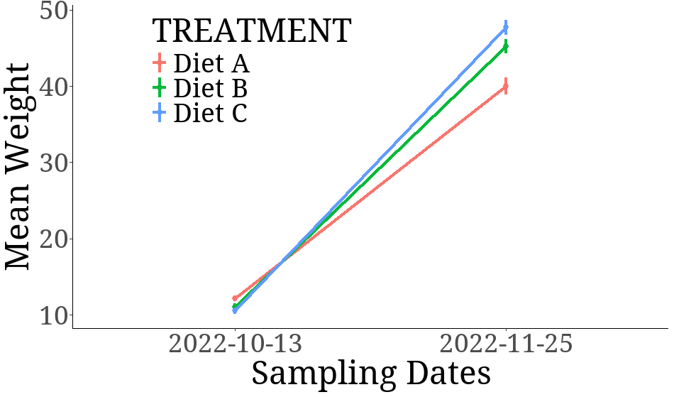

## Bars

